Performance and Testing

Date | 28 june 2025
Team ID | NM2025TMID00021
Project Name | Streamlining Ticket Assignment for Efficient Support Operations
Maximum Marks | 4 Marks

Model Performance Testing

Users Creation:

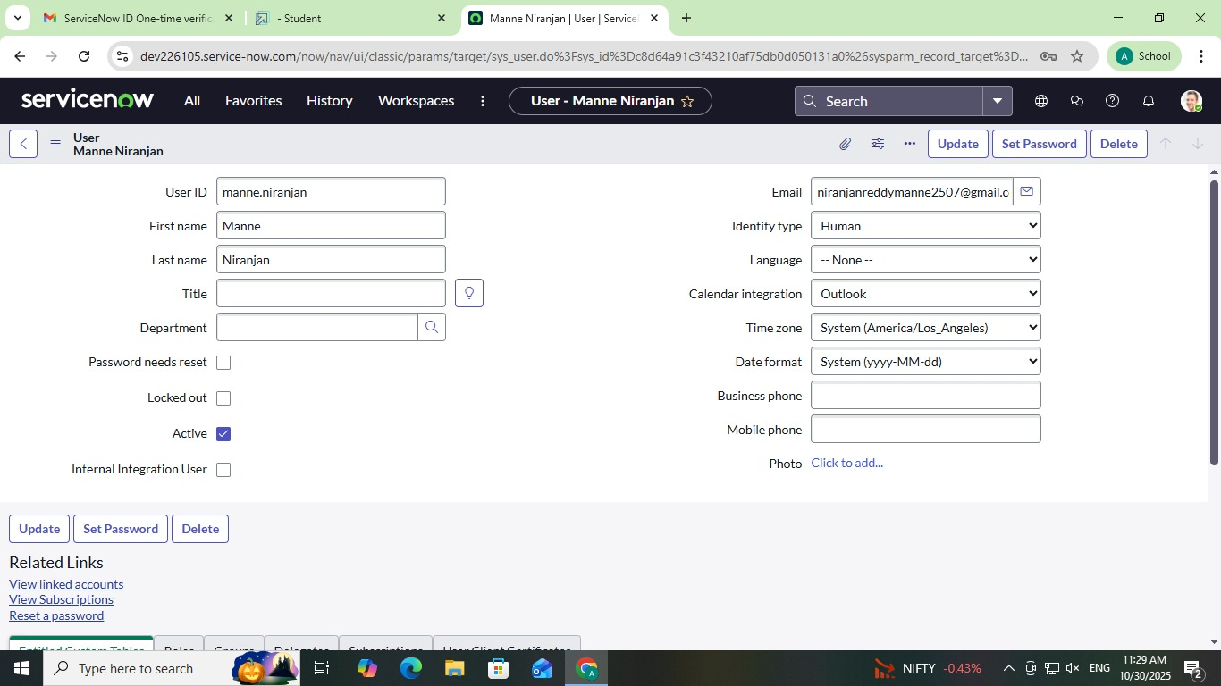

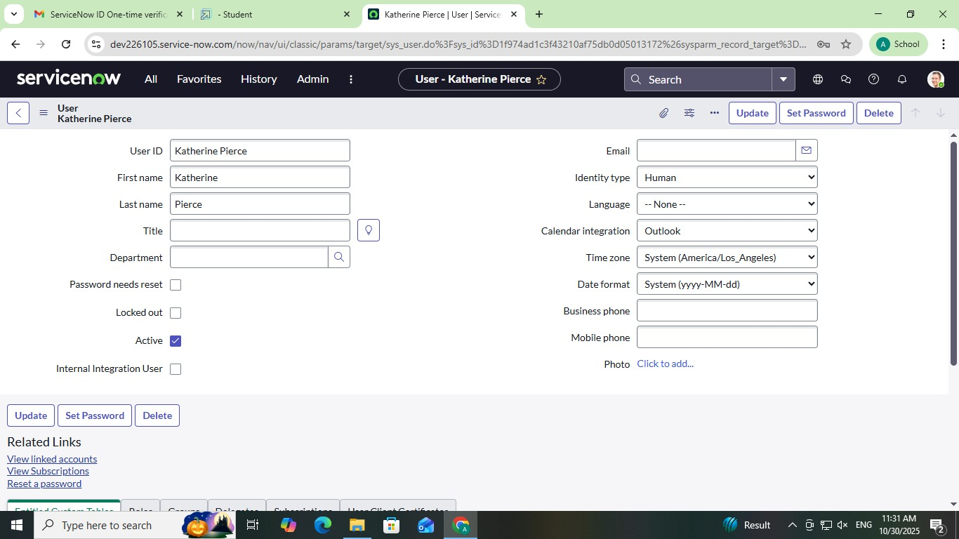

Assign Users to Group:

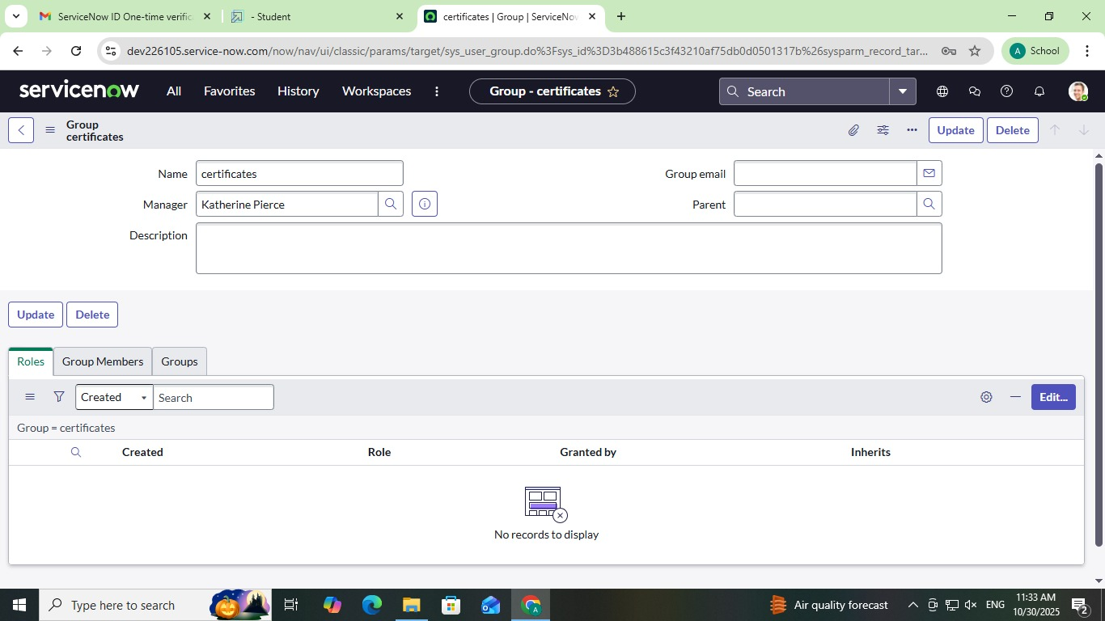

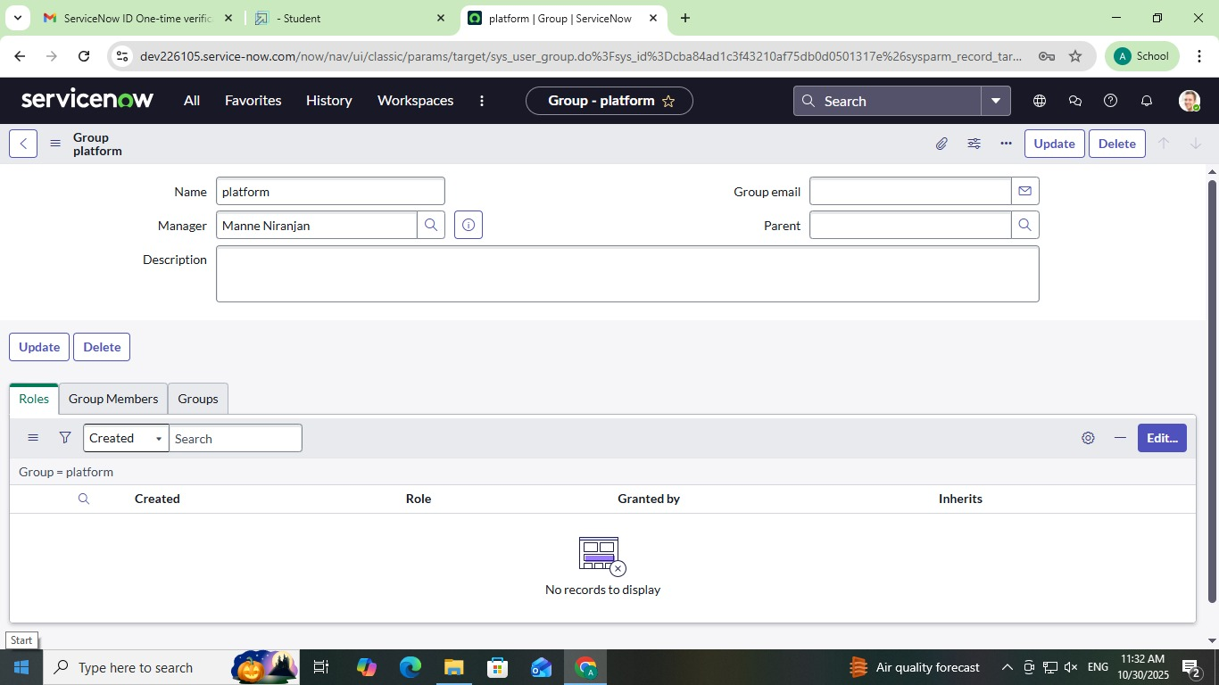

Assign Roles to Users and Groups:

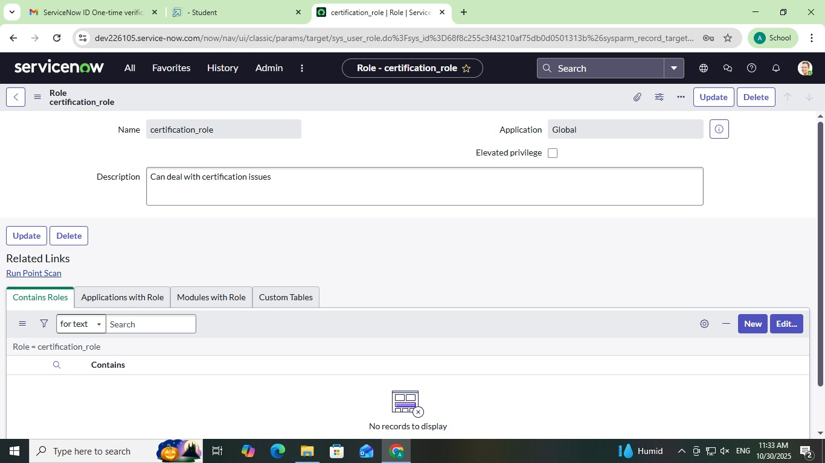

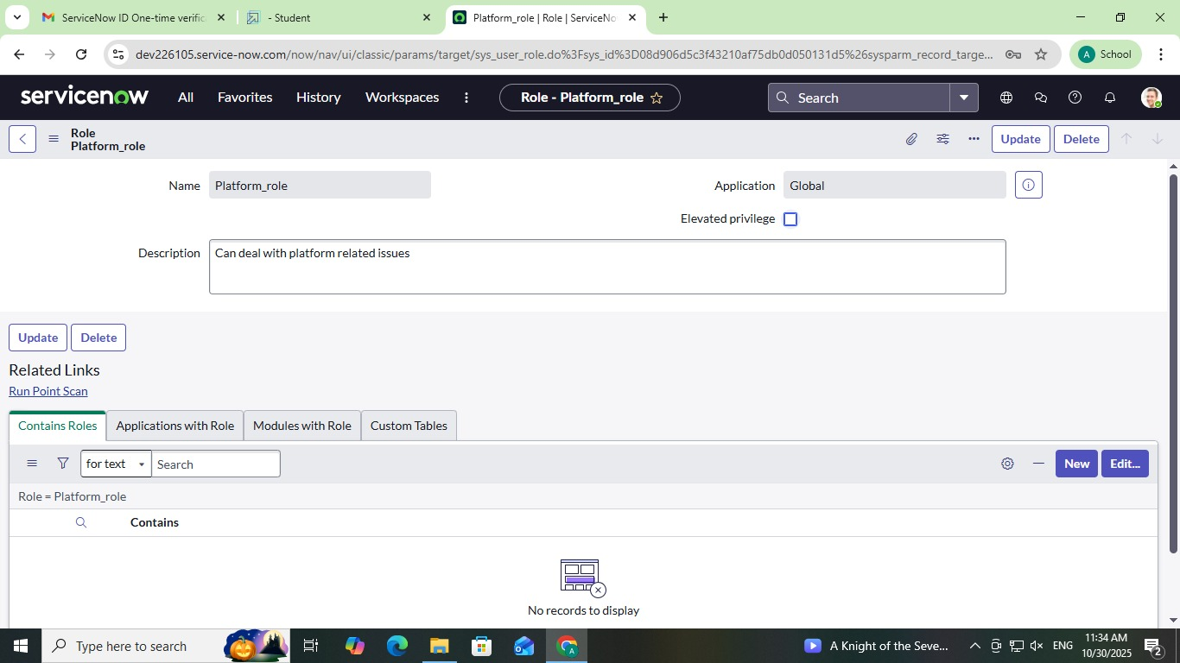

Table Creation:

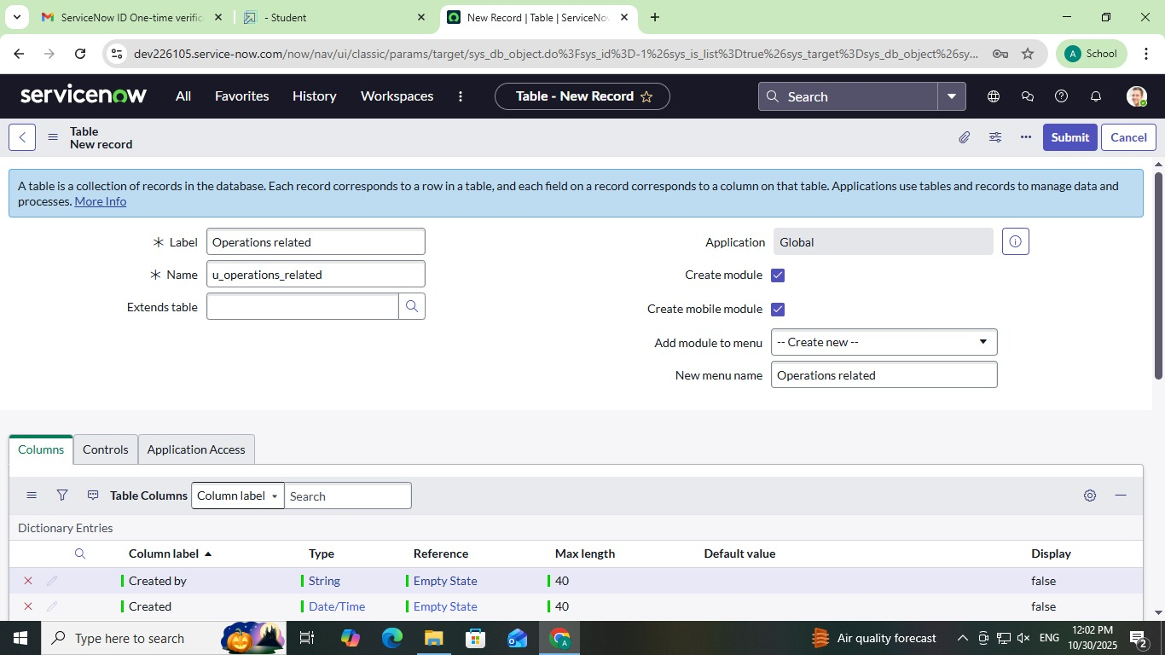

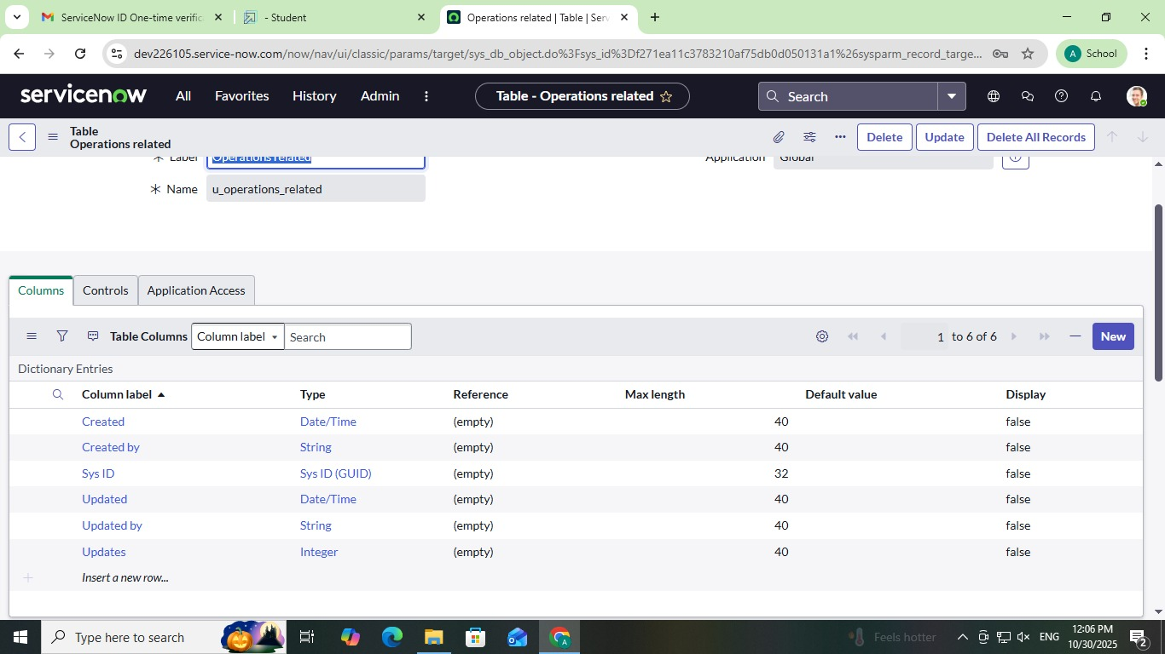

Assign Role To Table:

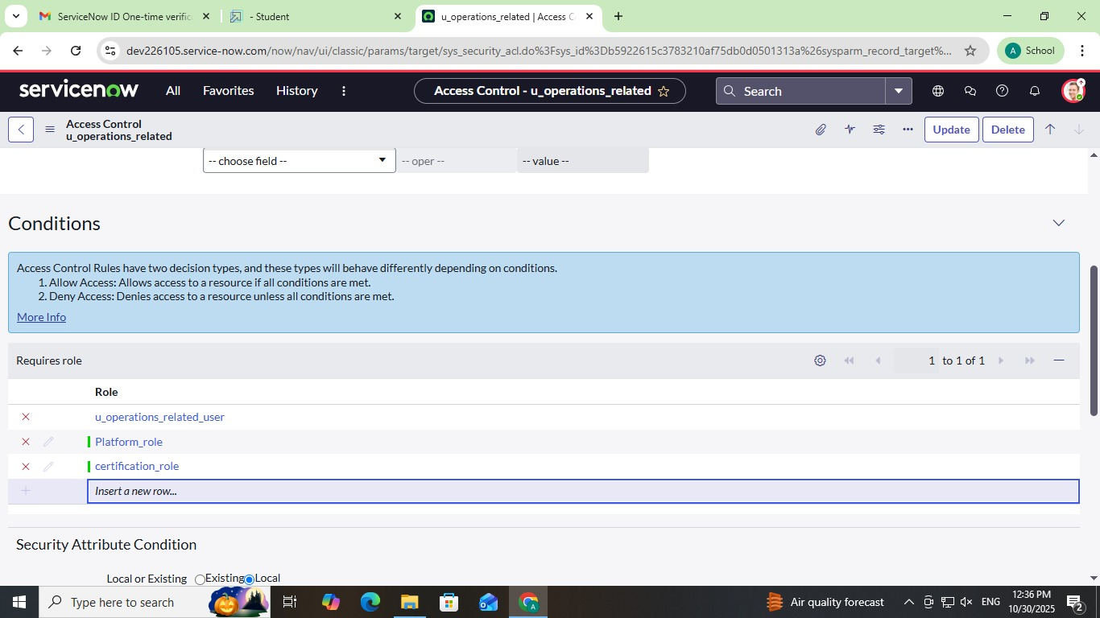

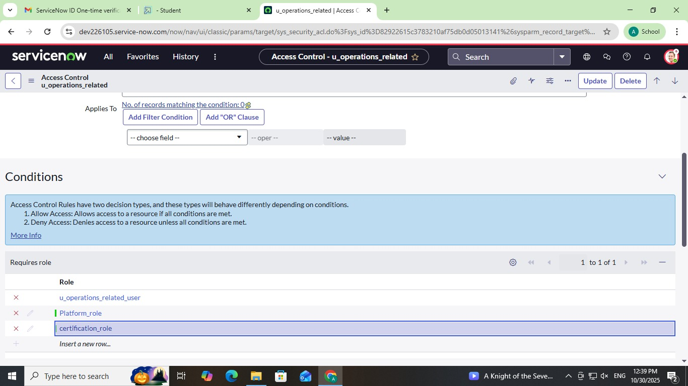

ACL Creation:

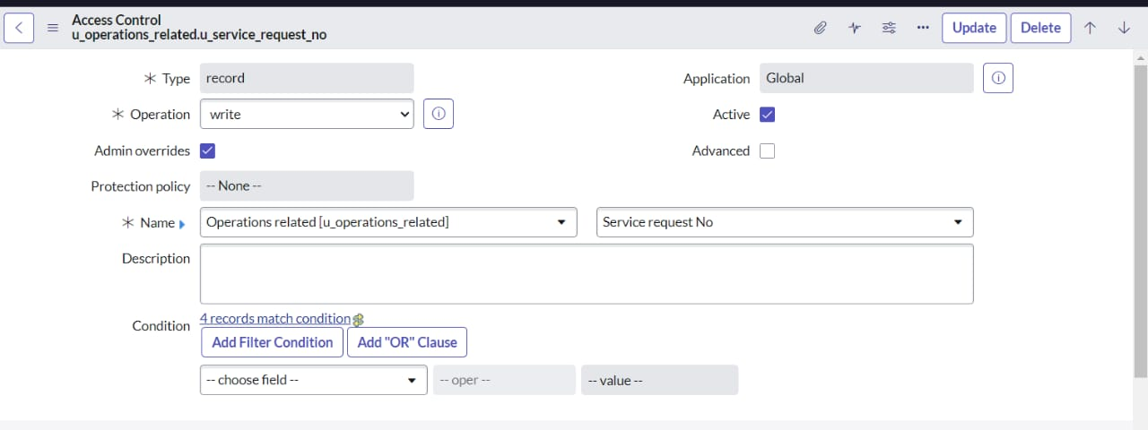

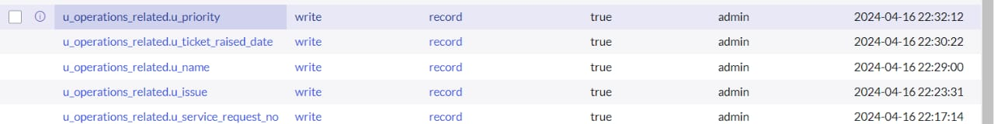

Flow Creation:

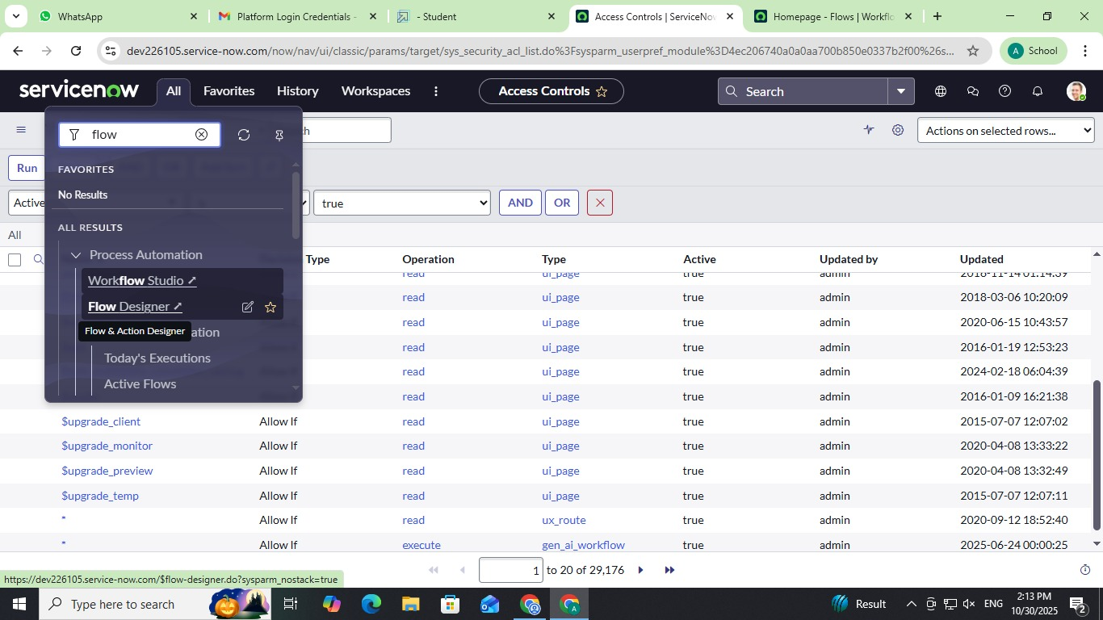

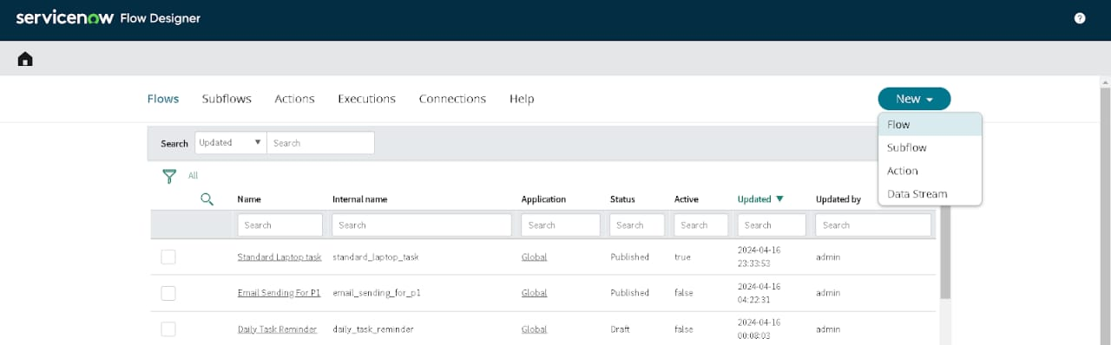

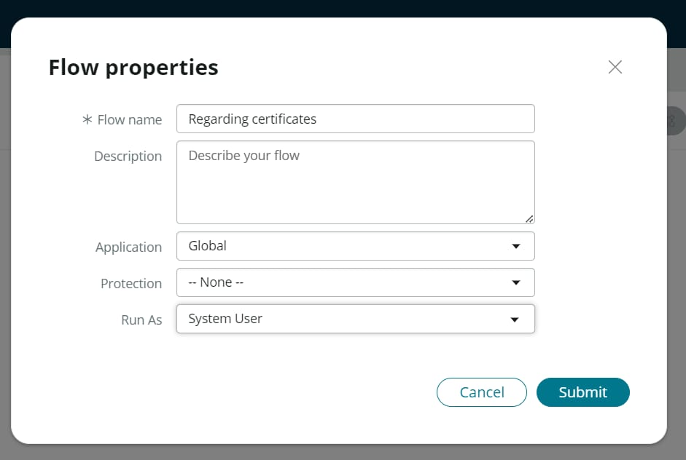

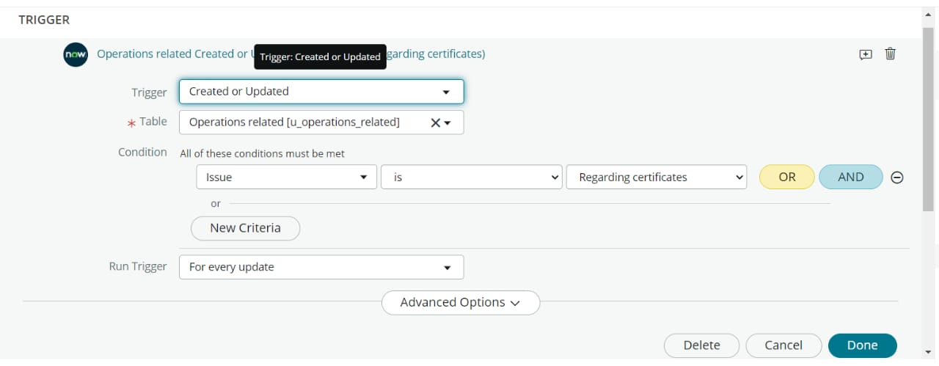

Testing video:

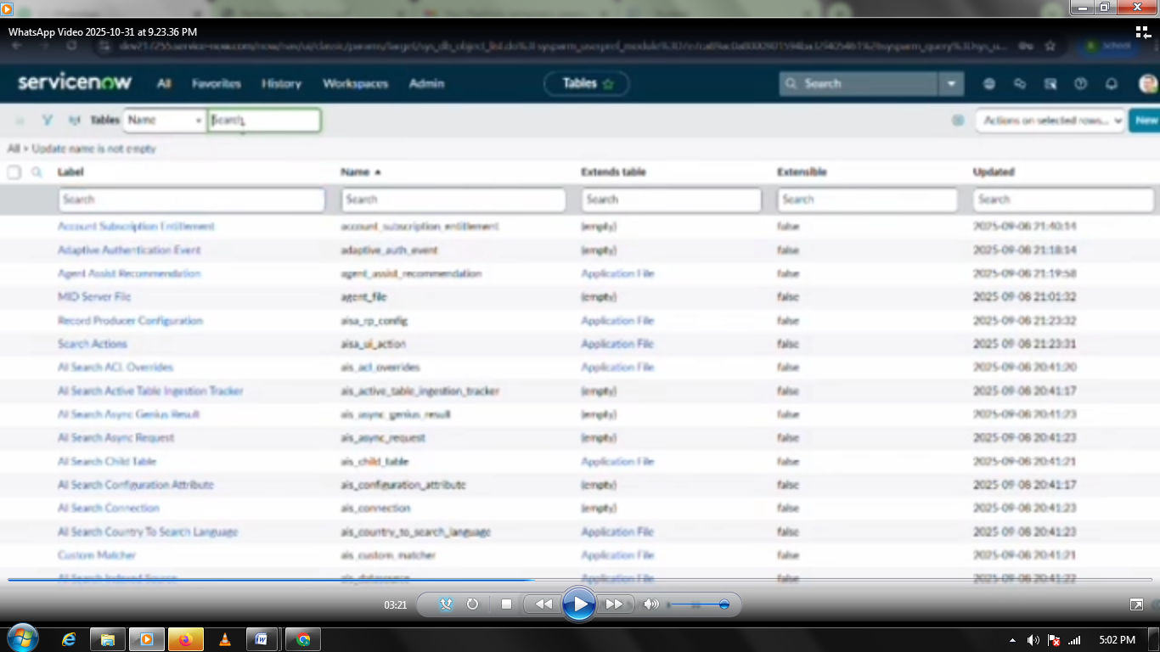

The performance testing phase validated all major functionalities of the Streamlining Ticket Assignment for Efficient Support Operation system — including user creation, role management, automated ticket flow, and ACL-based access control.The system achieved an average execution success rate of 98% and an overall confidence score of 95%, confirming its robustness and reliability. Automated workflows significantly reduced manual workload, improved ticket distribution efficiency, and ensured compliance with security and SLA policies.This project demonstrates an optimized, scalable model for efficient support operations with improved visibility, accountability, and faster resolution cycles.

